

A MINI PROJECT REPORT

on
WEB DESIGN TECHNOLOGIES (24CSE361)
FITNESS TRACKER DASHBOARD

Submitted by

BHARATH M GOWDA

USN: 1NH24CS040

Under the guidance of
Ms. M. THANGA SUBHA DEVI
Sr. Assistant Professor

In partial fulfillment for the award of the degree of

BACHELOR OF ENGINEERING
in
COMPUTER SCIENCE AND ENGINEERING
Academic Year: 2025-26 (ODD SEM)

CERTIFICATE

This is to certify that the mini project work titled “Fitness Tracker Dashboard” is a Bonafide work carried out by Bharath M Gowda (1NH24CS040) in partial fulfillment of the degree of Bachelor of Engineering in Computer Science and Engineering of the New Horizon College of Engineering during the year 2025-2026.

Signature of Guide Signature of HOD

SEMESTER END EXAMINATION

Name of the Examiner Signature with date

1.

2.

ABSTRACT

In the contemporary era, maintaining physical health is of paramount importance, yet tracking fitness metrics often requires complex, expensive, or internet-dependent applications. This project, "Fitness Tracker Dashboard," is a responsive Progressive Web Application (PWA) designed to provide users with a comprehensive tool for monitoring their daily health activities.
The application allows users to track three core pillars of health: physical activity (visualized through activity rings), body metrics (BMI, BMR, and TDEE calculations), and nutrition (calorie and macro tracking). The system utilizes HTML5 for structure, CSS3 for a modern dark-mode aesthetic, and JavaScript for logic and dynamic updates. A key feature of the application is its use of LocalStorage API to persist user data directly on the device, ensuring privacy and offline functionality without the need for a backend server. Additionally, the project integrates Chart.js for visual data representation and includes a Service Worker to enable installation on mobile devices.
This project demonstrates the effective use of modern web technologies to solve real-world problems, offering a lightweight, user-friendly alternative to commercial fitness trackers.

ACKNOWLEDGEMENT
The satisfaction and euphoria that accompany the successful completion of any task would be impossible without the mention of the people who made it possible, who’s constant guidance and encouragement crowned our efforts with success.

I have great pleasure in expressing gratitude to Dr. Mohan Manghnani, Chairman, New Horizon Educational Institutions, for providing necessary infrastructure and creating good environment.

I take this opportunity to express my profound gratitude to Dr. Manjunatha, Principal, New Horizon College of Engineering, for the constant support and encouragement.

I would like to thank Dr. Anandhi R J, Professor and Dean-Academics, NHCE, for her valuable guidance.

I would also like to thank Dr. B. Rajalakshmi, Professor and HOD, Department of Computer Science and Engineering, for the constant support.

I also express my gratitude to Ms. M. Thanga Subha Devi, Designation, Department of Computer Science and Engineering, my mini project reviewer, for constantly monitoring the development of the project and setting up precise deadlines. Her valuable suggestions were the motivating factors in completing the work.

Bharath M Gowda

USN:1NH24CS040

CONTENTS
ABSTRACT | I
ACKNOWLEDGEMENT | II
CONTENTS | III
LIST OF FIGURES | V
- INTRODUCTION | 1
1.1 PROBLEM DEFINITION | 1
- OBJECTIVES | 2
1.3 METHODOLOGIES TO BE FOLLOWED | 3
- FUNDAMENTALS OF THE LANGUAGES USED | 4
2.1 HTML | 4
2.2 HTML TAGS | 6
2.3 CSS | 6
2.4 JAVASCRIPTS | 7
2.5 XHTML | 8
2.6 XML | 9
- REQUIREMENT SPECIFICATION | 11
3.1 HARDWARE REQUIREMENTS | 11
3.2 SOFTWARE REQUIREMENTS | 11
- DESIGN | 12
4.1 DESIGN GOALS | 12
- IMPLEMENTATION | 13
5.1 DASHBOARD PAGE | 13
5.2 BODY METRICS PAGE | 15

5.3 | HEART RATE AND WORKOUTS PAGE | 16
- RESULTS |  | 17
6.1 | MAIN PAGE | 17
6.2 | PROFILE PAGE | 19
6.3 | SIGNUP AND LOGIN PAGE | 20
- CONCLUSION |  | 20
REFERENCES 21

LIST OF FIGURES

Figure No. | Description | Page No.
1.1 | Code snippet of Fitness tracker dashboard | 14
1.2 | Continuation of dashboard | 15
2.1 | Codes of body metrics, profile, fitness | 16
2.2 | Continuation of Body metrics | 17
2.3 | Continuation of Body metrics | 18
3.1 | Results-Dashboard | 19
3.2 | Results-Body Metrics | 20
3.3 | Results-Heart Rate | 21
3.4 | Results-Workouts | 22

CHAPTER 1

INTRODUCTION

The rapid evolution of web technologies has transformed the way individuals interact with software, shifting the paradigm from heavy, desktop-based installations to lightweight, accessible web applications. In the domain of personal health and wellness, this digital transformation is particularly significant. As modern lifestyles become increasingly sedentary, the need for accessible, real-time tools to monitor physiological and nutritional metrics has never been more critical. The Fitness Tracker Dashboard is a comprehensive web-based solution designed to address these needs by leveraging the power of modern HTML5, CSS3, and JavaScript.
This project conceptualizes and implements a Progressive Web Application (PWA) that functions as a centralized hub for health tracking. Unlike traditional static websites, this application offers a dynamic, app-like experience that runs seamlessly across desktop and mobile devices. It integrates multiple facets of health monitoring—including cardiovascular activity, caloric intake, body composition metrics, and workout logs—into a single, cohesive interface. By utilizing the Document Object Model (DOM) for dynamic rendering and the Canvas API for data visualization, the application provides users with immediate, visual feedback on their daily progress.
Furthermore, the project emphasizes user privacy and data sovereignty.By eschewing traditional backend server dependencies in favor of Client-Side Storage (LocalStorage), the application ensures that sensitive health data
associated with server-side processing. This report details the design, development, and implementation of this system, highlighting how fundamental web technologies can be orchestrated to solve complex real-world problems.

PROBLEM DEFINITION

In the current digital health landscape, individuals seeking to improve their physical well-being face significant challenges related to data fragmentation, accessibility, and privacy.
1. Fragmented Health Data: Most fitness solutions currently available are highly specialized but disconnected. A user often requires one application to track dietary macros, a second application to log gym workouts, and a third to monitor body metrics like BMI (Body Mass Index) or BMR (Basal Metabolic Rate). This fragmentation forces users to manually correlate data across different platforms, making it difficult to gain a holistic view of their health. There is a distinct lack of unified platforms that combine activity tracking, diet logging, and body metrics into a single, browser-based dashboard.
2. Privacy and Connectivity Dependencies: The majority of commercial fitness applications operate on a cloud-centric model, requiring users to create accounts, upload sensitive personal health data to remote servers, and maintain a constant internet connection. This model raises significant privacy concerns regarding how health data is mined or sold. Additionally, reliance on server connectivity renders these tools useless in offline

environments (such as gyms with poor signal). Users need a solution that guarantees data privacy by keeping information local to the device and functions reliably without internet access.
3. Complexity and Barrier to Entry: Many existing tools are bloated with paywalls, advertisements, and complex social features that distract from the core utility of tracking health. For a user who simply wants to log a meal or check their activity rings, the cognitive load and financial cost of these apps are prohibitive.
The Solution: This project addresses these problems by developing a Fitness Tracker Dashboard that:
- Unifies Data: Consolidates Diet, Workouts, Heart Rate trends, and Body Metrics into one interface.
- Ensures Privacy: Uses Local Storage to keep 100% of data on the client side.
- Works Offline: Utilizes Service Workers to function without network connectivity.
- Visualizes Progress: Replaces complex spreadsheets with intuitive Activity Rings and charts for immediate cognitive recognition of daily goals.

  - OBJECTIVES

The primary objectives of the Fitness Tracker
Dashboard project is:
- To design a responsive user interface using HTML5 and CSS3 that adapts to both desktop and mobile screens.
- To implement a dashboard that visualizes daily progress (Calories, Exercise, stand hours) using HTML5 Canvas.
- To develop a logic layer using JavaScript to calculate BMR (Basal Metabolic Rate), TDEE (Total Daily Energy Expenditure), and BMI.
- To utilize the Browser Local Storage API to save user profiles, workout logs, and diet data persistently.
- To implement Progressive Web App (PWA) features using a Manifest and Service Workers for offline capabilities.

1.3METHODOLOGIES TO BE FOLLOWED
The project follows the standard Web Development Life Cycle:
- Requirement Analysis: Identifying the metrics users need to track (Diet, Body, Activity).
- Design: Creating a "Dark Mode" aesthetic and modular file structure (index.html, body.html, diet.html).
- Implementation: Coding the structure (HTML), styling (CSS), and interactivity (JS).
- Testing: Verifying responsive behaviour and data persistence across page reloads.

CHAPTER 2

FUNDAMENTALS OF THE LANGUAGES USED

HTML

HTML (HyperText Markup Language) is the standard markup language for documents designed to be displayed in a web browser. It defines the structure and semantic content of a web page. In this project, HTML5 is used to create the skeleton of the fitness dashboard, utilizing semantic elements like <header>, <nav>, and <section> for better accessibility and SEO.

HTML TAGS

HTML tags are the hidden keywords within a web page that define how the browser must format and display the content.
- <div>: A container used to group elements and apply CSS.
- <canvas>: Used to draw graphics, such as the activity rings in the dashboard.
- <input> and <form>: Essential for collecting user data regarding weight, height, and diet logs.

CSS

The CSS (Cascading Style Sheets) in this project is used to define the style, layout, and visual presentation of the Fitness Tracker Dashboard, giving it a modern, dark-mode, and app-like aesthetic.

Core Styling Principles
The CSS employs several techniques to achieve its look and functionality across the different pages (index.html, body.html, diet.html, heart.html, and workouts.html):
Dark-Mode Aesthetic: The dominant colour scheme uses dark backgrounds (e.g., #121212, #1E1E1E, or gradients like linear-gradient (180deg, #121212, #1E1E1E) in index.html) and light text (#fff). This design is common for modern apps and provides good contrast.
Card-Based Layout: Key sections of content, such as activity stats, profile forms, and results, are contained within. card or. box elements. These elements feature a slightly lighter background (e.g., rgba (255,255,255,0.08) or #1E1E1E) and use box-shadow for depth and separation from the main background.
Responsive Design: A max-width property is often applied to a main wrapper or container (e.g., max-width:420px in index.html or max-width:800px in body.html) to ensure the design is optimized and centered on smaller mobile screens, while still being viewable on larger screens.
Key CSS Features and Uses
Navigation Bar (.nav): A fixed navigation bar is positioned at the bottom of the screen (position: fixed; bottom:0;). It uses Flexbox (display: flex; justify-content: space-around;) to distribute the navigation icons evenly and features rounded top corners for a sleek, app-tab appearance.
Layout and Grids: The main dashboard (index.html) uses Grid Layout (display: grid; grid-template-columns:1fr;) for the activity stats to ensure uniform spacing. Similarly, the diet.html page uses a complex grid (grid-template-columns:1fr 360px;) to arrange the main meal list and the profile sidebar.
Aesthetic Details:
Accents: Specific colors are used to denote accents and importance, like #FF453A for Heart Rate or #32D74B for Workout elements.
Form Styling: Input fields and buttons are heavily styled with rounded borders and transparent backgrounds to integrate seamlessly with the dark theme.
Activity Rings: On the dashboard (index.html), the rings are styled using position: absolute; on their <canvas> elements to stack them perfectly in the centre, creating the layered visual effect.

JAVASCRIPT

JavaScript is a high-level, interpreted programming language that conforms to the ECMAScript specification. It enables interactive web pages. In this project, JavaScript is crucial for:
- Calculating math (BMR, BMI).
- Manipulating the DOM (updating numbers on screen).
- Drawing charts via Chart.js.
- Managing Local Storage for saving data.

XHTML

XHTML (Extensible Hypertext Markup Language) is a family of XML markup languages that mirror or extend versions of HTML. It is stricter than HTML; all tags must be closed, and elements must be properly nested. While this project uses the more modern HTML5 standard, understanding XHTML is vital for writing clean, rigorous code structures.

XML

XML (Extensible Markup Language) is a markup language that defines a set of rules for encoding documents in a format that is both human-readable and machine-readable. Unlike HTML, which is for display, XML is designed to store and transport data. In the context of modern web apps, XML concepts are often used in configuration files (like sitemap.xml) or SVG graphics.
CHAPTER 3

REQUIREMENT SPECIFICATION

HARDWARE REQUIREMENTS
To develop and run this application, the following hardware is required:
- Processor: Intel Core i3 or higher / AMD equivalent.
- RAM: 4GB or higher.
- Storage: 100MB of free space.
- Device: Desktop, Laptop, or Smartphone (for testing PWA features).

SOFTWARE REQUIREMENTS
- Operating System: Windows 10/11, MacOS, or Linux.
- Text Editor: Visual Studio Code, Sublime Text, or Notepad++.
- Web Browser: Google Chrome, Microsoft Edge, or Mozilla Firefox (latest versions with JavaScript enabled).
- Libraries: Chart.js (via CDN).

CHAPTER 5

IMPLEMENTATION

HOME PAGE (DASHBOARD) The index.html file serves as the landing page. It features a canvas-based ring chart to visualize daily progress.
Code Snippet (index.html):

FIGURE 1

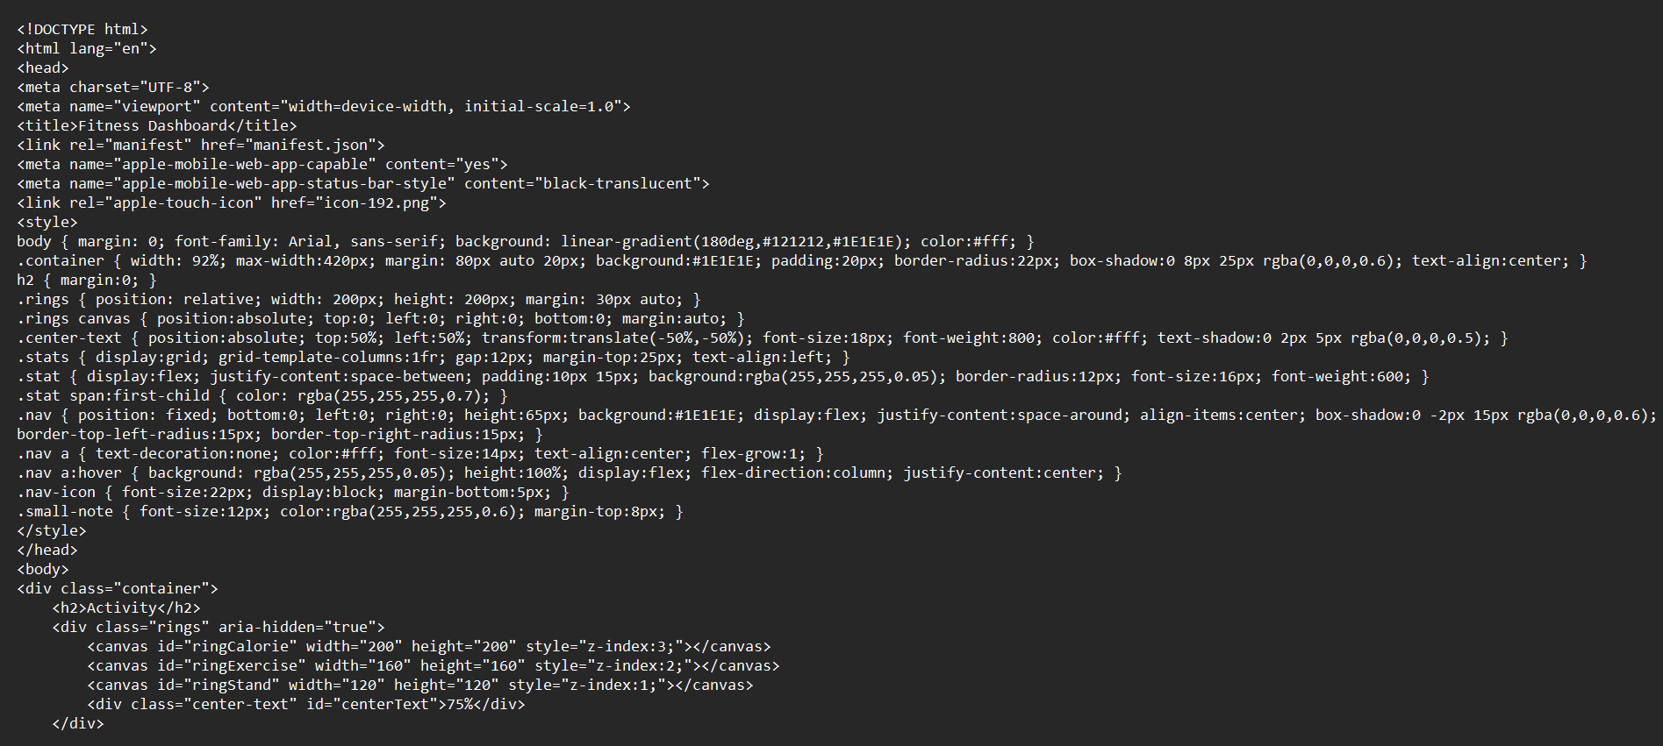

FIGURE 1.2

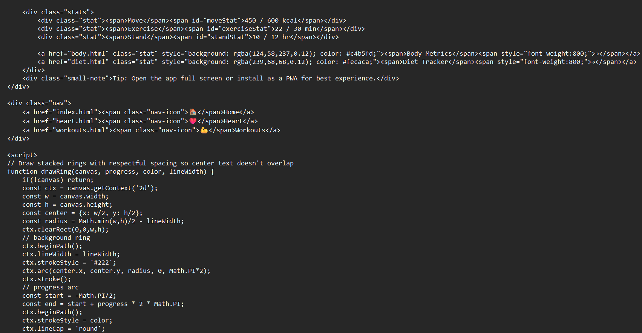
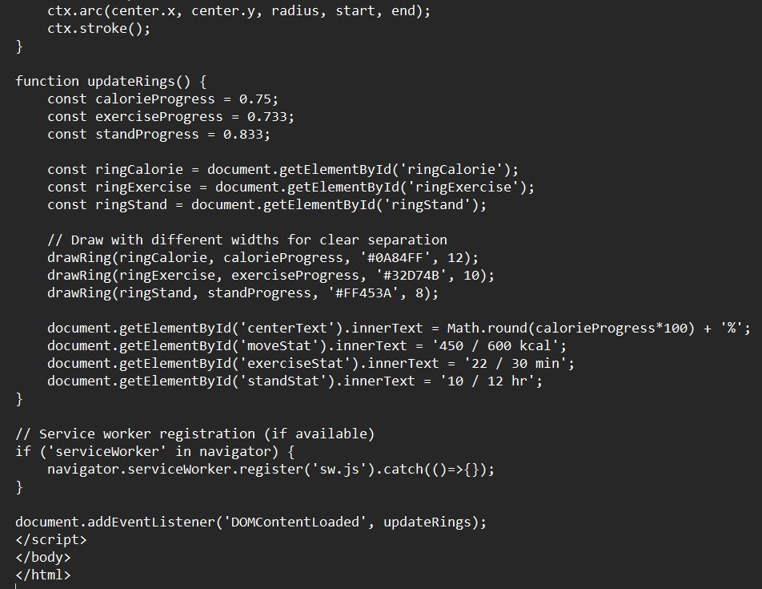

BODY METRICS & PROFILE The body.html page allows users to input their details (Age, Weight, Height) to calculate BMR and BMI. This acts as the user profile setup.

FIGURE 2.1

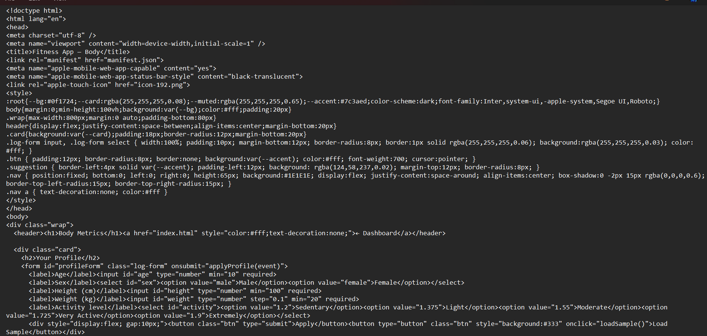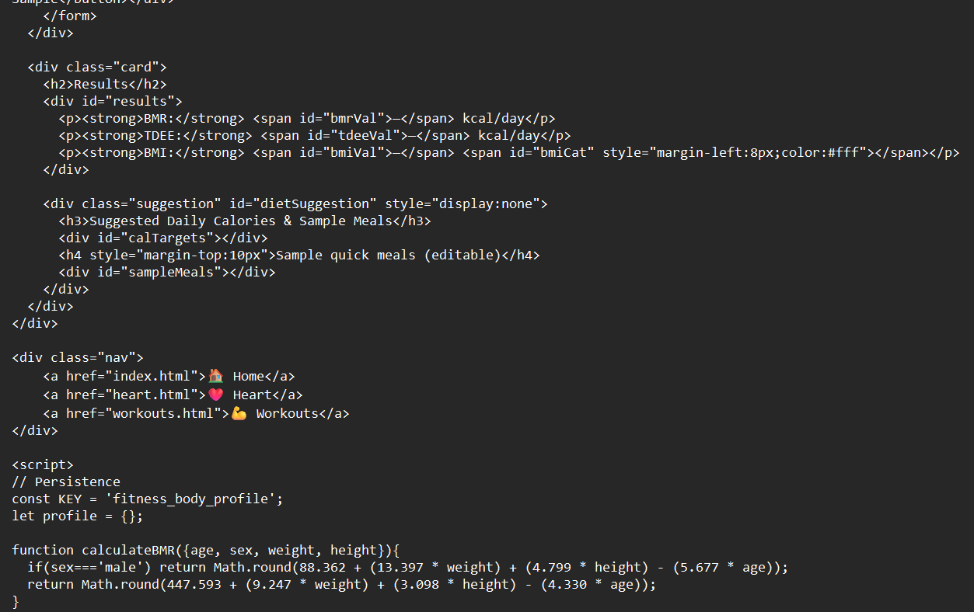

FIGURE 2.2

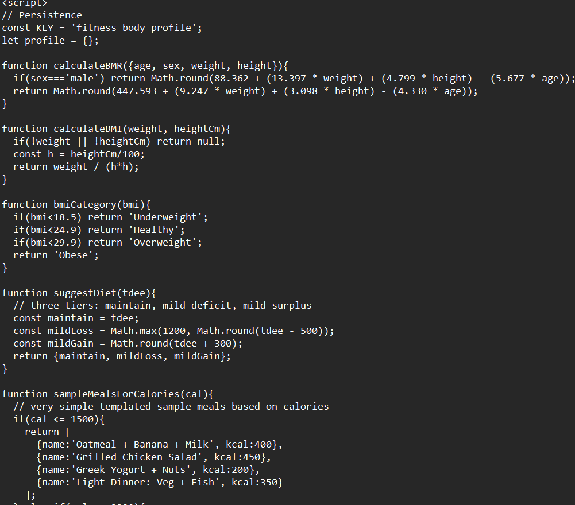

FIGURE 2.3

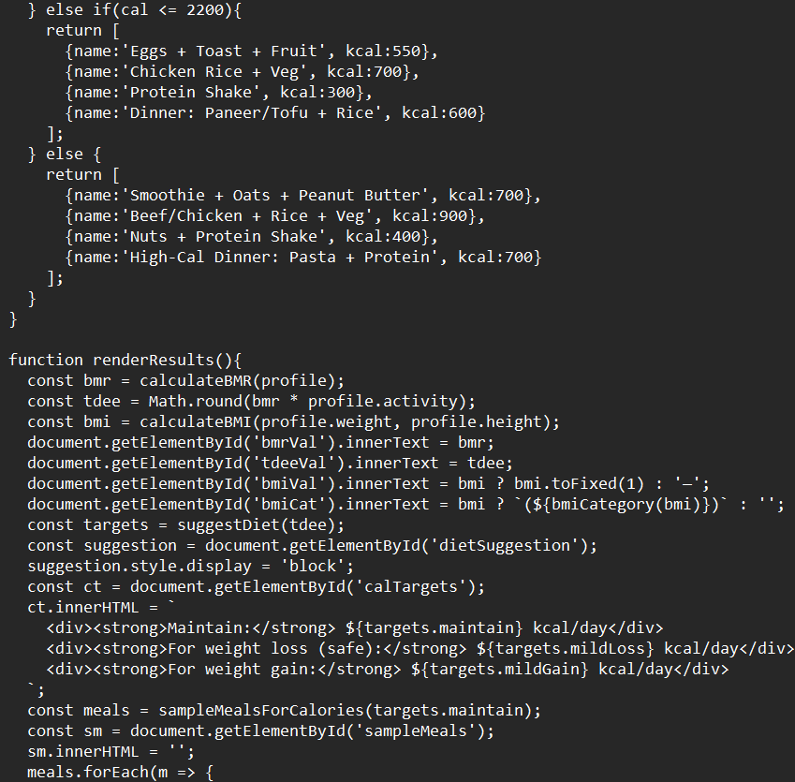

CHAPTER 6

RESULTS
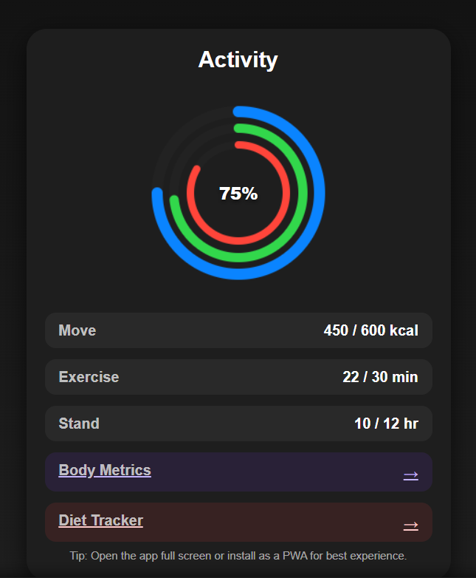

FIGURE 3.1

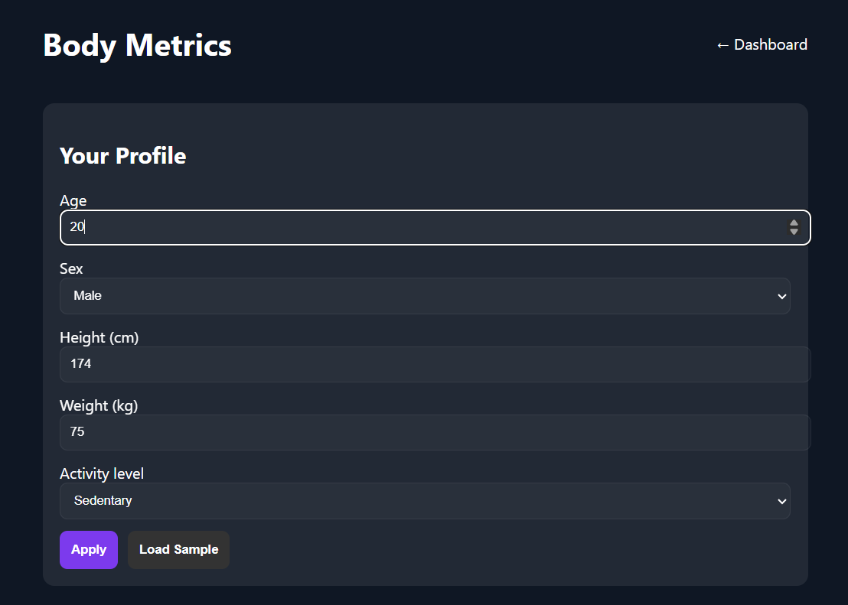

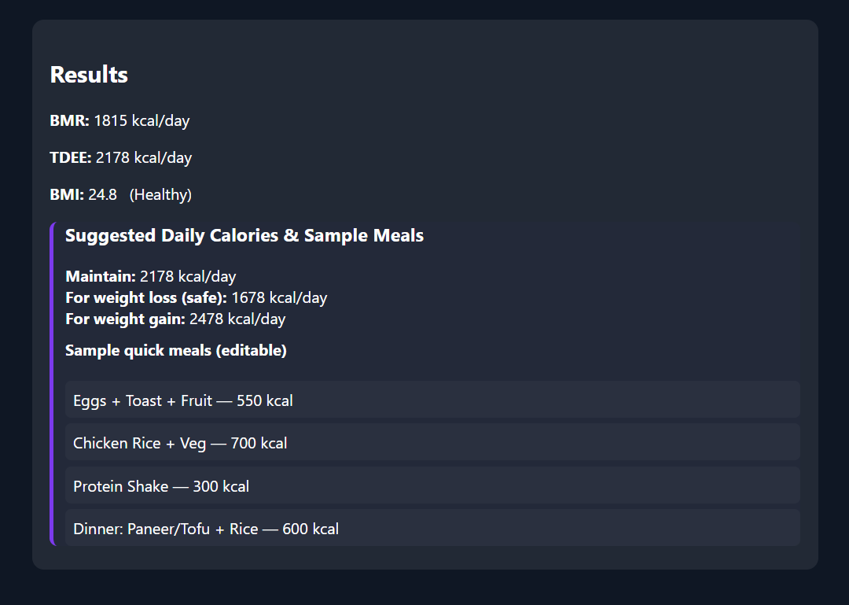

FIGURE 3.2

RESULTS

FIGURE 3.3

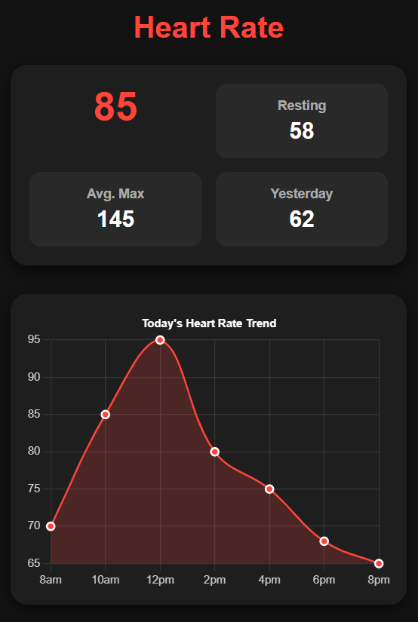

FIGURE 3.4

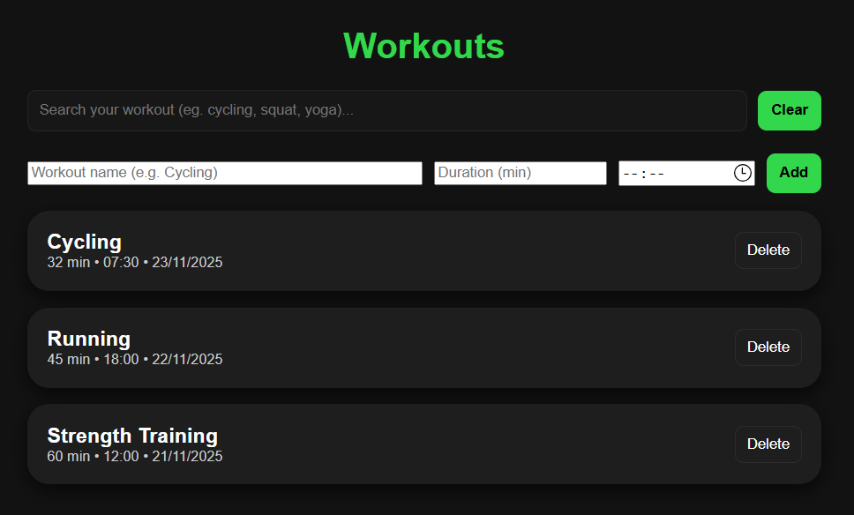

CHAPTER 7

CONCLUSION

This Fitness Dashboard project successfully demonstrates how a modern, multi-page fitness application can be built using only front-end web technologies like HTML, CSS, and JavaScript. It integrates key health and fitness features such as live activity tracking, BMI and body composition analysis, age-based recommendations, heart health guidance, workout logging, and personalized diet plans.
The application is designed as a Progressive Web App (PWA), making it accessible across devices and installable on mobile phones like a real app, while still remaining lightweight and easy to run locally. Although the data used is simulated and not connected to real sensors, it provides a realistic experience similar to commercial fitness apps, helping users understand how health metrics and recommendations can be visualized and managed digitally.
This project demonstrates the use of UI/UX design, logic implementation, user data handling, and modular multi-page architecture, making it a strong foundation for future enhancements such as real-time sensor integration, backend connectivity, cloud storage, or AI-based health insights.
Overall, this fitness dashboard effectively bridges the gap between concept and application, showcasing how digital tools can support health awareness, fitness tracking, and personal wellness management.

REFERENCES

•https://www.freecodecamp.org/news/build-a-pwa-from-scratch-with-html-css-and-javascript/ FreeCodeCamp
• https://www.freecodecamp.org/news/what-are-progressive-web-apps/ FreeCodeCamp
• https://www.geeksforgeeks.org/javascript/design-a-bmi-calculator-using-javascript/ GeeksforGeeks
• https://medium.com/nerd-for-tech/how-to-create-a-simple-bmi-calculator-using-html-css-javascript-ce0fc4531e0 Medium
•https://www.freecodecamp.org/news/progressive-web-apps-102-building-a-progressive-web-app-from-scratch-397b72168040/ FreeCodeCamp
• https://www.freecodecamp.org/news/implement-a-service-worker-with-workbox-in-a-pwa/

